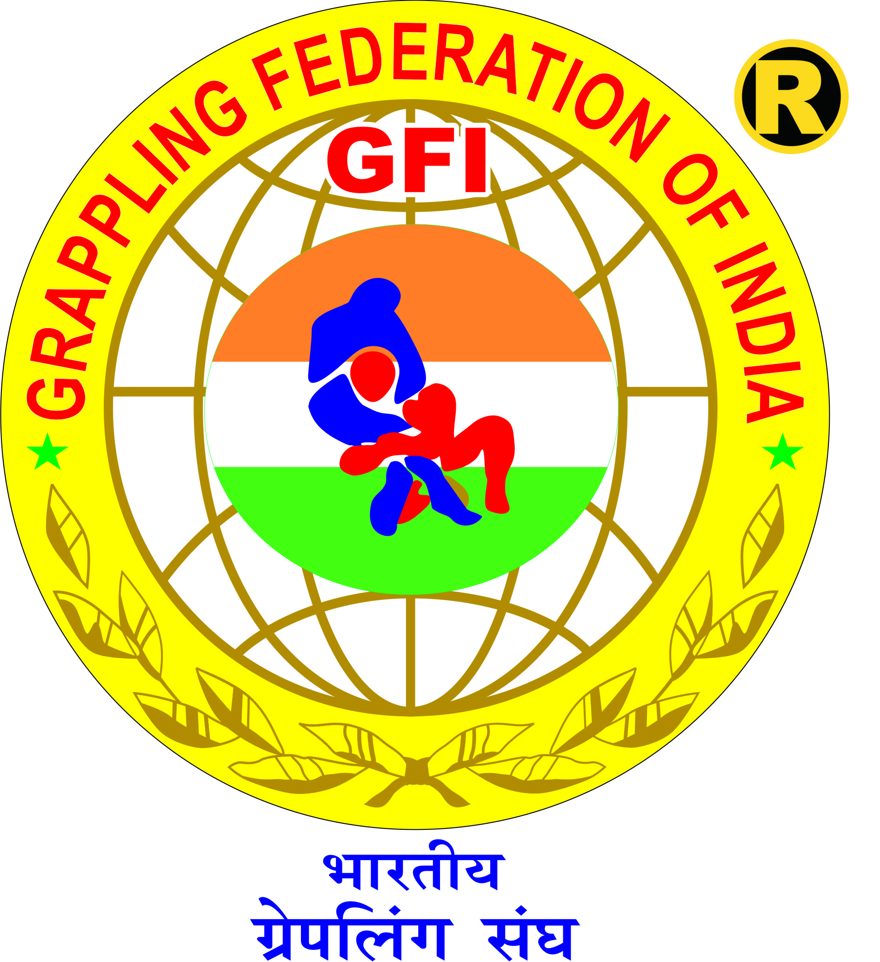 |  |  |  |  | 16th GFI NATIONAL GRAPPLING CHAMPIONSHIP 2023  (Sub. Juniors, Cadets, Juniors, Seniors, & Veterans)  Organised By : Amateur Grappling Sports Association of MP  Recognized By : UNITED WORLD WRESTLING  Shrimant Tukoji Rao Pawar Indoor Stadium, Bhopal Square, Dewas, MP  1 - 4 June, 2023
ATHLETE REGISTRATION APPLICATION FORM
Fill the entire Form COMPUTER TYPED and in BLOCK LETTERS only

I the undersigned hereby apply to participate in
16TH GFI NATIONAL GRAPPLING CHAMPIONSHIP - 2023 (Sub. Juniors, Cadets, Juniors, Seniors, & Veterans) to be held in Shrimant Tukoji Rao Pawar Indoor Stadium, Bhopal Square, Dewas, MP during 1-4 June, 2023

Athlete’s Name |  |  |  |  |  |  |  |  |  |  |  | PASTE  STAMP SIZED  CURRENT COLORED  PHOTO
Father’s / Mother’s Name
Sex |  | DOB |  |  |  |  | Age Category
Weight |  |  |  |  |  |  | Weight Category
Event Category |  |  | NOGI GI |  |  |  |  |  |  | Mobile No.
Email ID |  |  |  |  |  |  |  |  |  | WhatsApp No.
Full Address
District |  |  |  |  |  |  |  | City/Village
State/UT Association
State/UT Representative
SIGNATURES (with date)
All information mentioned above and all Documents attached herewith are true to the best of my knowledge.
Athlete |  |  |  | Parent/Guardian  (For Minor’s Only) |  | Coach |  |  | State Representative |  | GFI Office

Mandatory Attachments with Application Form :

- 2 Stamp Sized CURRENT COLORED PHOTOS
- IDENTITY PROOF :
- For Participant above 18 Years of age on the day of the Championship
1 Photocopy of Aadhaar Card / Passport
- For Participant below 18 Years of age on the day of the Championship
1 Photocopy of Aadhaar Card / Passport / Educational Institution Current Identity Card
+ Signatory Parent’s/Guardian’s 1 Photocopy of Aadhaar Card / Passport
- MEDICAL CERTIFICATE & DECLARATION
- CONSENT FORM (In case of Minor)

